**LP Gas Leakage Monitoring System**

* **Megha Katigar**

**Table of Content**

**Abstract**

**1. Description**

**1.1.Objectives**

**2. Requirements**

**2.1 High Level requirements**

**2.2 Low Level requirement**

**3. Block Diagram**

**3.1 Component Required**

**3.1.1 Atmega328P Microcontroller**

**3.1.2 Sensors**

**3.1.2.1 temperature Sensor**

**3.1.2.2 Smoke Sensor**

**3.1.3 Actuators**

**3.1.3.1 Dc motor**

**3.1.3.2 Servo motor**

**3.1.3.3 Buzzer**

**3.1.4 Communication Modules**

**3.1.4.1 GPS Module**

**3.1.4.2 GSM Module**

**3.1.5 LCD**

**4. Behavioral Diagram**

**5. Flow Chart**

**6. Schematic Diagram**

**7. Test Plan**

**7.1 High Level test plan**

**7.2 Low Level test plan**

**8. Application**

**9. Future Scope**

**Abstract**

The significance of a fire alarm system in maintaining and monitoring the safety of all types of surroundings and circumstances is critical. However, many existing fire alarm systems are well-known for their utility, yet they can be produced at a high cost. As a result, it is out of reach for low-income individuals. The major goal of this project is to create a low-cost fire control system. The detecting system, monitoring system, and appliance system are the three primary systems in the project. The detecting system functions as both a fire and a smoke detector.

The GSM is used for sending SMS services, buzzer for alarming, servos for automatic lockdown of doors in emergency exits, motor pump fire extinguishing foam to stop the fire, and GPS module to indicate the location where the fire occurred for the fire extinguishing vehicle are all components of the appliance system. The microcontroller is in responsible for the total system.

The system can detect smoke, flame, heat, and other elements detected by the detector, followed by a monitoring system that displays smoke, light, flame, heat, and other elements at that level. Finally, the main Buzzer activates and sends SMS when the sensors from each level are independently triggered. The control panel LCD display then displays which areas are damaged and which are safe. Then it activates the emergency exit servo motor for escape and the water pump motor for fire suppression in the affected zone.

**1. Description**

This system functions as a self-contained embedded system. It's a completely self-contained unit. It accepts digital or analog inputs through its input ports, calibrates, transforms, and processes the data, and then sends the results to an attached output device, which either displays data or controls and drives the attached devices. For example, these devices may use the Global System for Mobile Communication (GSM) and short message service (SMS) to transmit data from the building to the owners' mobile phones. As a result, by employing GSM technology to send immediate alert notification messages to owners or the fire brigade, it is easier to control fire damage. Microcontrollers will control variables such as temperature and smoke level. Each of these parameters is monitored by a sensor that is calibrated to a specified range; if the sensor detects a change in that range, the system will take the necessary action, and the user will receive a daily report through SMS.

**1.1Objectives**

* To indicate the location where the fire is occurred.
* To prevent fire and smoke.
* To sound the alarm if fire occurs.
* To run the emergency EXIT servo motor and control the fire by supplying water to the remote area by motor pump.

**2. Requirements**

* 1. **High Level Requirements**

|  |  |  |
| --- | --- | --- |
| ID | Title | Description |
| HLL_01 | **Gas Sensor** | **It shall sense the gas leakage** |
| HLL_02 | **LCD** | **It shall display the message** |
| HLL_03 | **Temperature Sensor** | **It shall measure the room temperature** |
| HLL_04 | **Servo motor** | **It shall spray water on fire** |
| HLL_05 | **GSM Module** | **It shall send a message to fire extinguisher when the fire takes place** |
| HLL_06 | **Buzzer** | **It shall notify the neighbors that the fire or gas leakage taken place** |

* 1. **Low Level Requirements**

|  |  |  |
| --- | --- | --- |
| ID | Title | Descript |
| LLR_1.1 | **Gas Leakage** | Home appliances that generates heat or gas such as stove, water heater |
| LLR_3.1 | **Fire Detection** | **This can be caused by gas leakage in room** |

**3. Block Diagram**

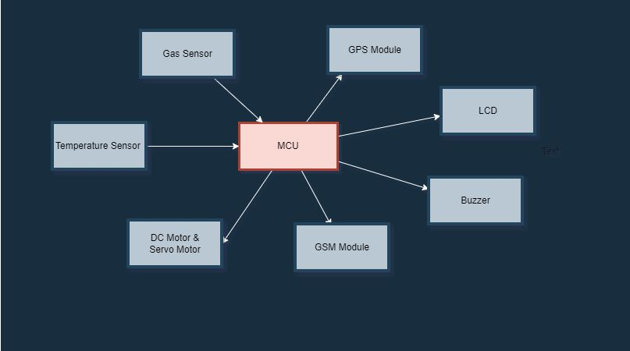

**3.1 Components required:**

**3.1.1 ATmega328P Microcontroller**

This microcontroller is a low-power CMOS (Complementary Metal Oxide Semiconductor) 8-bitmicrocontroller based on the AVR enhanced RISC (Reduced Instruction Set Computer) architecture. The powerful execution of instructions in a single clock cycle leads to the achievement of 1 MIPS per MHz throughputs allowing the designer to optimize power consumption versus processing speed.

**3.1.2Sensor**

**3.1.2.1Temperature Sensor**

The LM35 series are precision integrated-circuit temperature sensors, whose output voltage is linearly proportional to the Celsius (Centigrade) temperature. The LM35 thus has an advantage over linear temperature sensors calibrated in° Kelvin, as the user is not required to subtract a large constant voltage from its output to obtain convenient Centigrade scaling.

**3.1.2.2 Smoke Sensor**

The MQ-2 smoke sensor reports smoke by the voltage level that it outputs. The more smoke there is, the greater the voltage that it outputs. Conversely, the less smoke that it is exposed to, the less voltage it outputs. The MQ-2 also has a built-in potentiometer to adjust the sensitivity to smoke. By adjusting the potentiometer, you can change how sensitive it is to smoke, so it's a form of calibrating itto adjust how much voltage it will put out in relation to the smoke it is exposed to.

**3.1.3 Actuators**

**3.1.3.1 DC Motor**

A DC motor is a mechanically commutated electric motor powered from direct current (DC).The stator is stationary in space by definition and therefore the current in the rotor is switched by the commentator to also be stationary in space. This is how the relative angle between the stator and rotor magnetic flux is maintained near 90 degrees, which generates the maximum torque.

**3.1.3.2 Servo motor**

Inside a servo motor, there are a small DC motor, potentiometer, and a control circuit. The motor is attached by gears to the control wheel. The motor rotates, the potentiometer's resistance changes, so the control circuit can precisely regulate how much movement there is and in which direction. The servo motor in this project operates on 6V.

**3.1.3.3 Buzzer**

For alarm purposes a lot of electric bells, alarms and buzzers are available in the market that has got different prices and uses. The buzzer being used in this project is a 5-12 V buzzer and has got enough alarm sound to be used in a fire alarm system. Louder buzzer would have been even better but then their operating voltages are high as we had a supply of maximum up to 12V available with us on the board

**3.1.4** **Communication modules**

**3.1.4.1 GPS Module**

GPS or Global Positioning System is a satellite navigation system that furnishes location and time information in all climate conditions to the user. GPS is used for navigation in planes, ships, cars and trucks also. The system gives critical abilities to military and civilian users around the globe.

**3.1.4.2 GSM Module**

The acronym GSM is presently understood to mean Global System for Mobile Communications. We chose the SIM 900A because that our county Ethiopia support the SIM 900 2G network. It requires SIM (Subscriber Identity Module) card just like mobile phones to activate communication with the network. Also they have IMEI (International Mobile Equipment Identity) number similar to mobile phones for their identification.

**3.1.5 LCD**

A Liquid Crystal Display commonly abbreviated as LCD is basically a display unit built using *Liquid Crystal technology*. When we build real life/real world electronics based projects, we need a medium/device to display output values and messages. Liquid Crystal Displays comes in different size specifications. Out of all available LCD modules in market, the most commonly used one is 16×2LCD Module which can display 32 ASCII characters in 2 lines (16 characters in 1 line).

**4. Behavioral diagram**

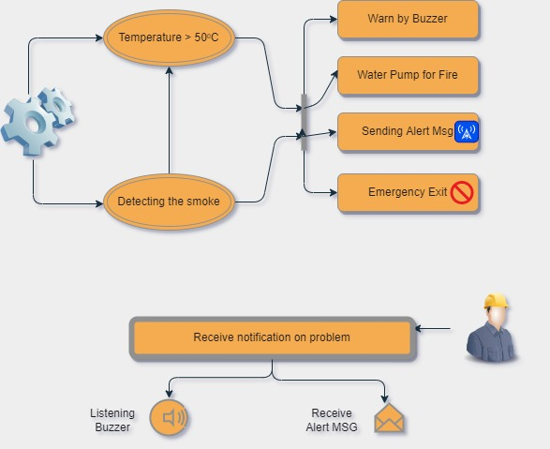

**5. Flow Chart**

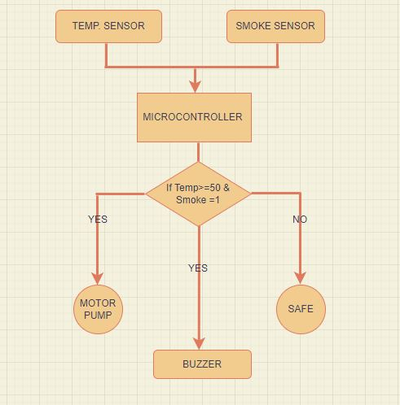

**6. Schematic Diagram**

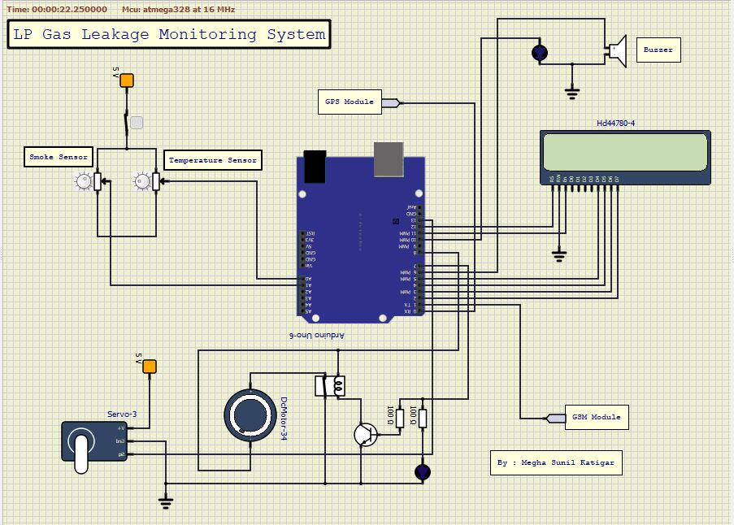

**7. Test Plan**

**7.1 High Level Test Plan**

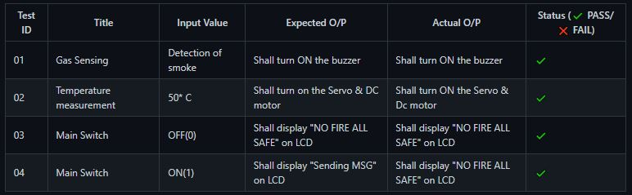

**7.2 Low level Test Plan**

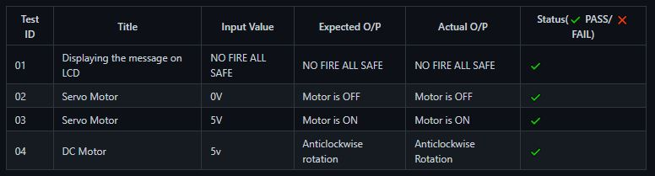

**8. Application**

1) Home

2) Factories

3) Industries

4) Apartments

5) Malls

**9. Future Scope**

The project can be extended by increasing the number of sensors used along with an increase in the number of installation places. The remote management of electronic devices can also be extended with the use of different real electronic devices. Using DC motor control automatically turns off the knob of the cylinder. So continuously monitoring the level of the LPG present in the cylinder using weight sensor and automatically books the cylinder using a GSM module.

**References**

* LP GAS LEAKAGE ALARM, SAITM Research Symposium on Engineering Advancements 2013At: Colombo, Sri Lanka.
* Smoke Detector Alarm, https://create.arduino.cc/projecthub/biharilifehacker/how-to-make-smoke-detector-alarm-1c322b
* https://www.academia.edu
* https://github.com/joranvg/arduino-atmega328p-a